**Assignment – 3**

**• Use the Employee Details dataset and perform the following activities: -**

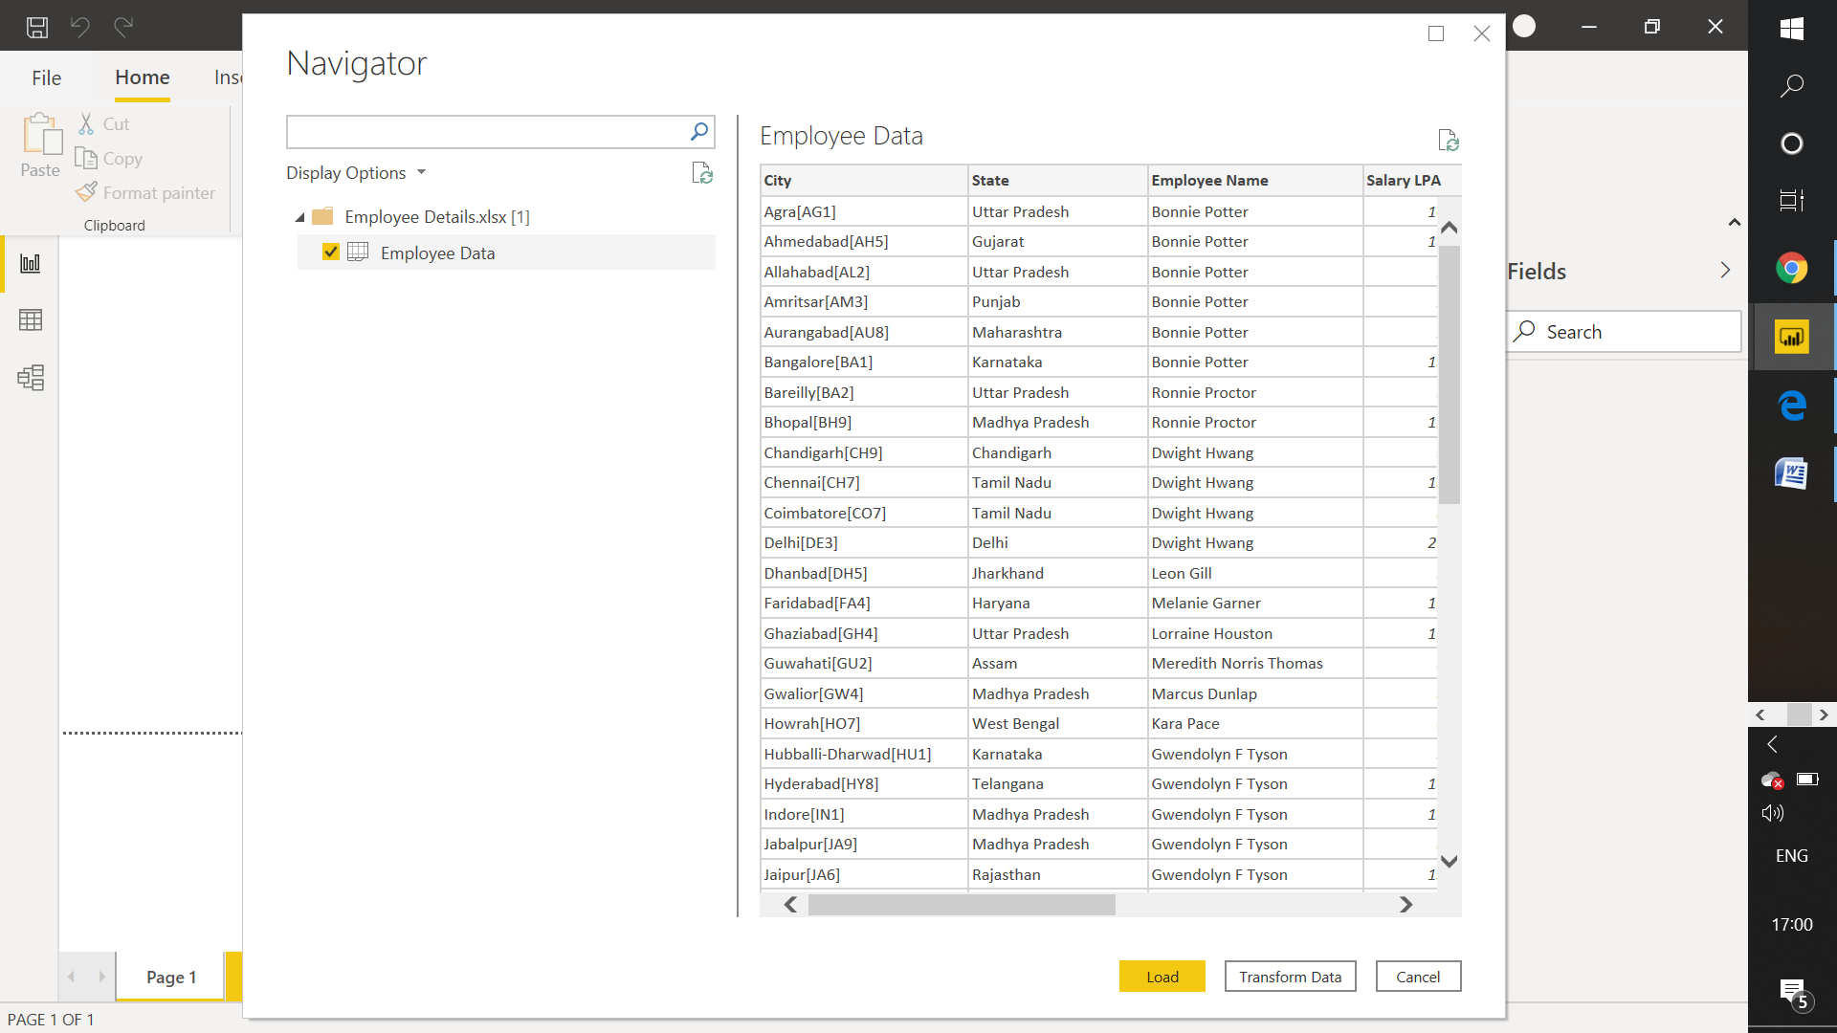

**− Split the column CITY and separate the code associate with each city like - Allahabad[AL2] should be only Allahabad and [A2] will be separate.**

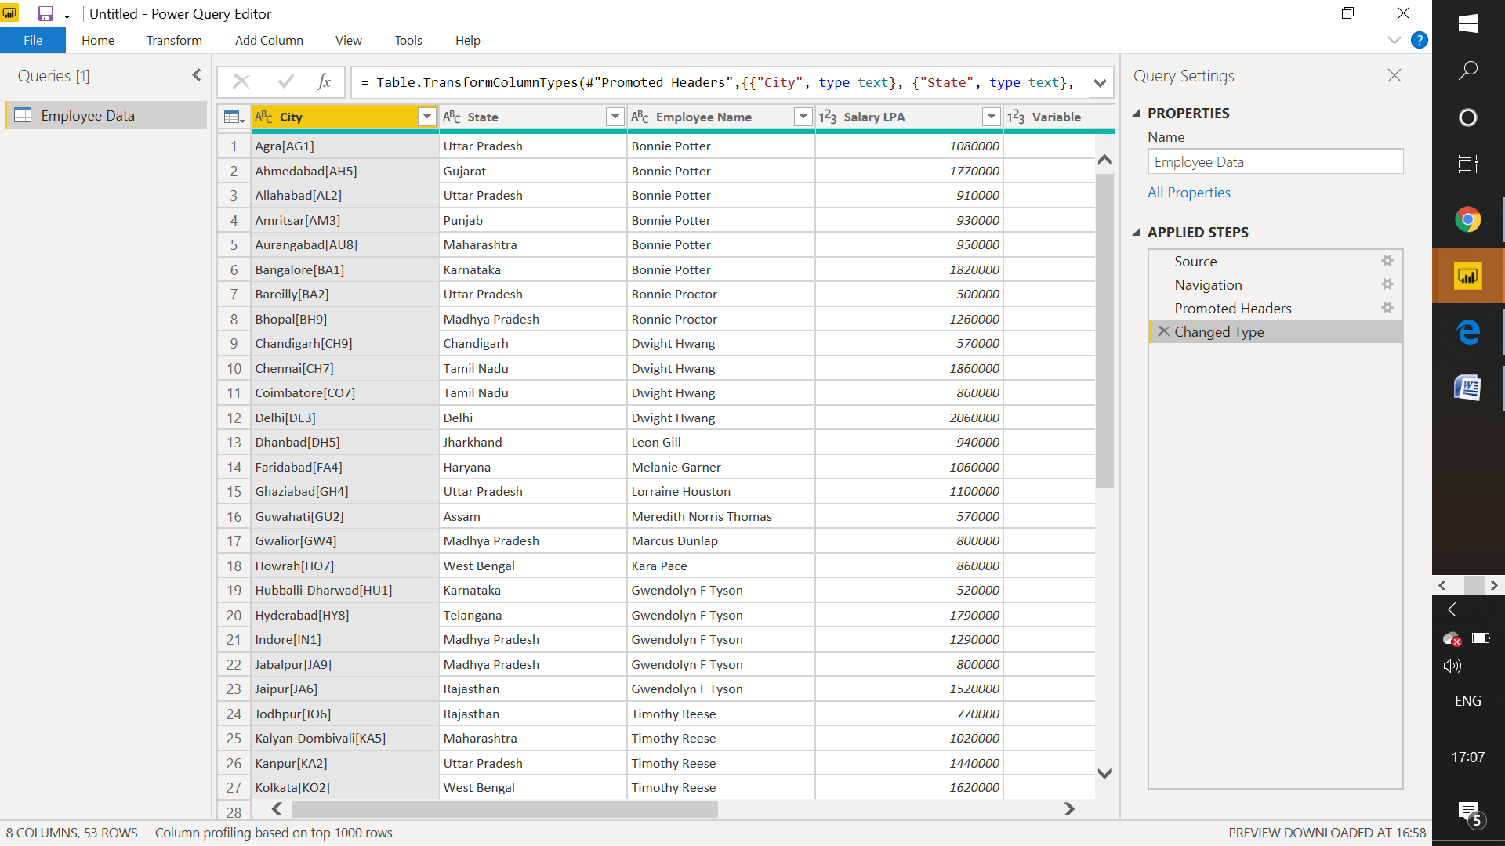

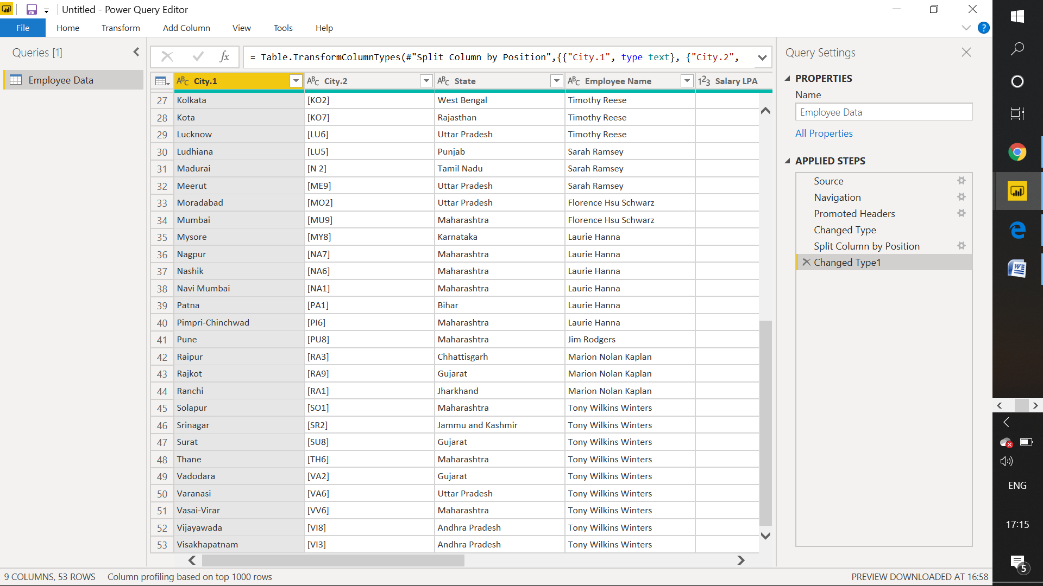

**− Extract the first name from EMPLOYEE NAME column and transform the column.**

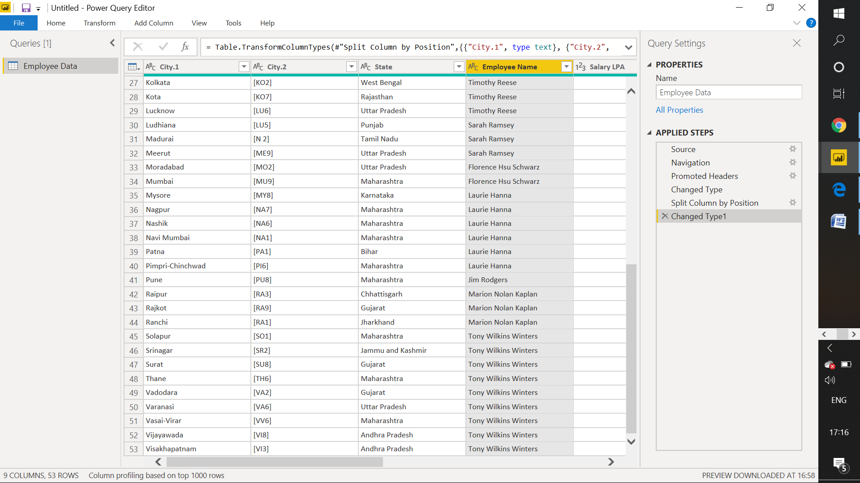

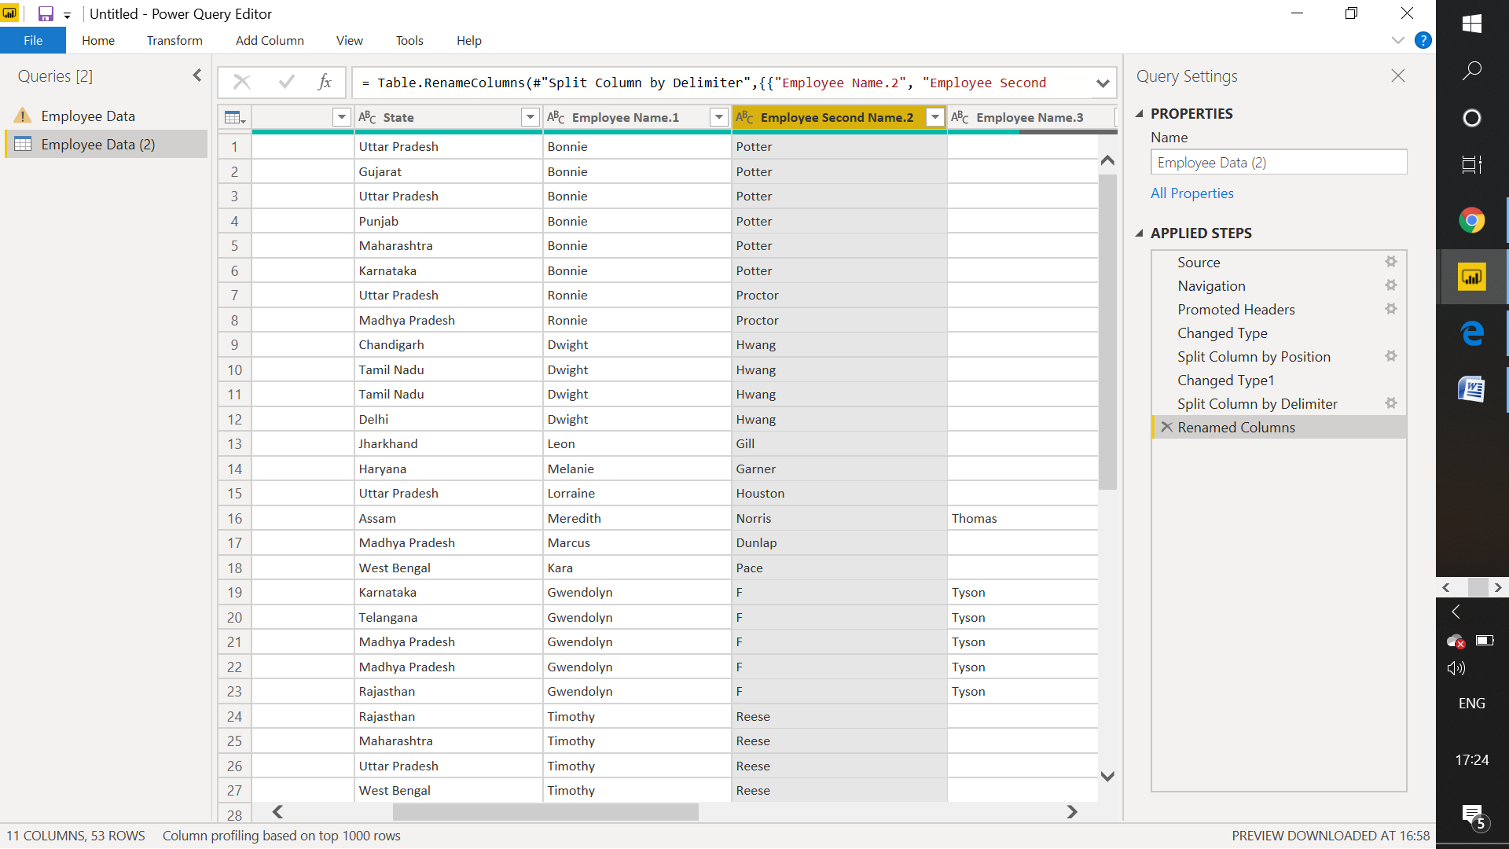

**− Using the JOINING DATE column extract the Year and no. of days for that month .**

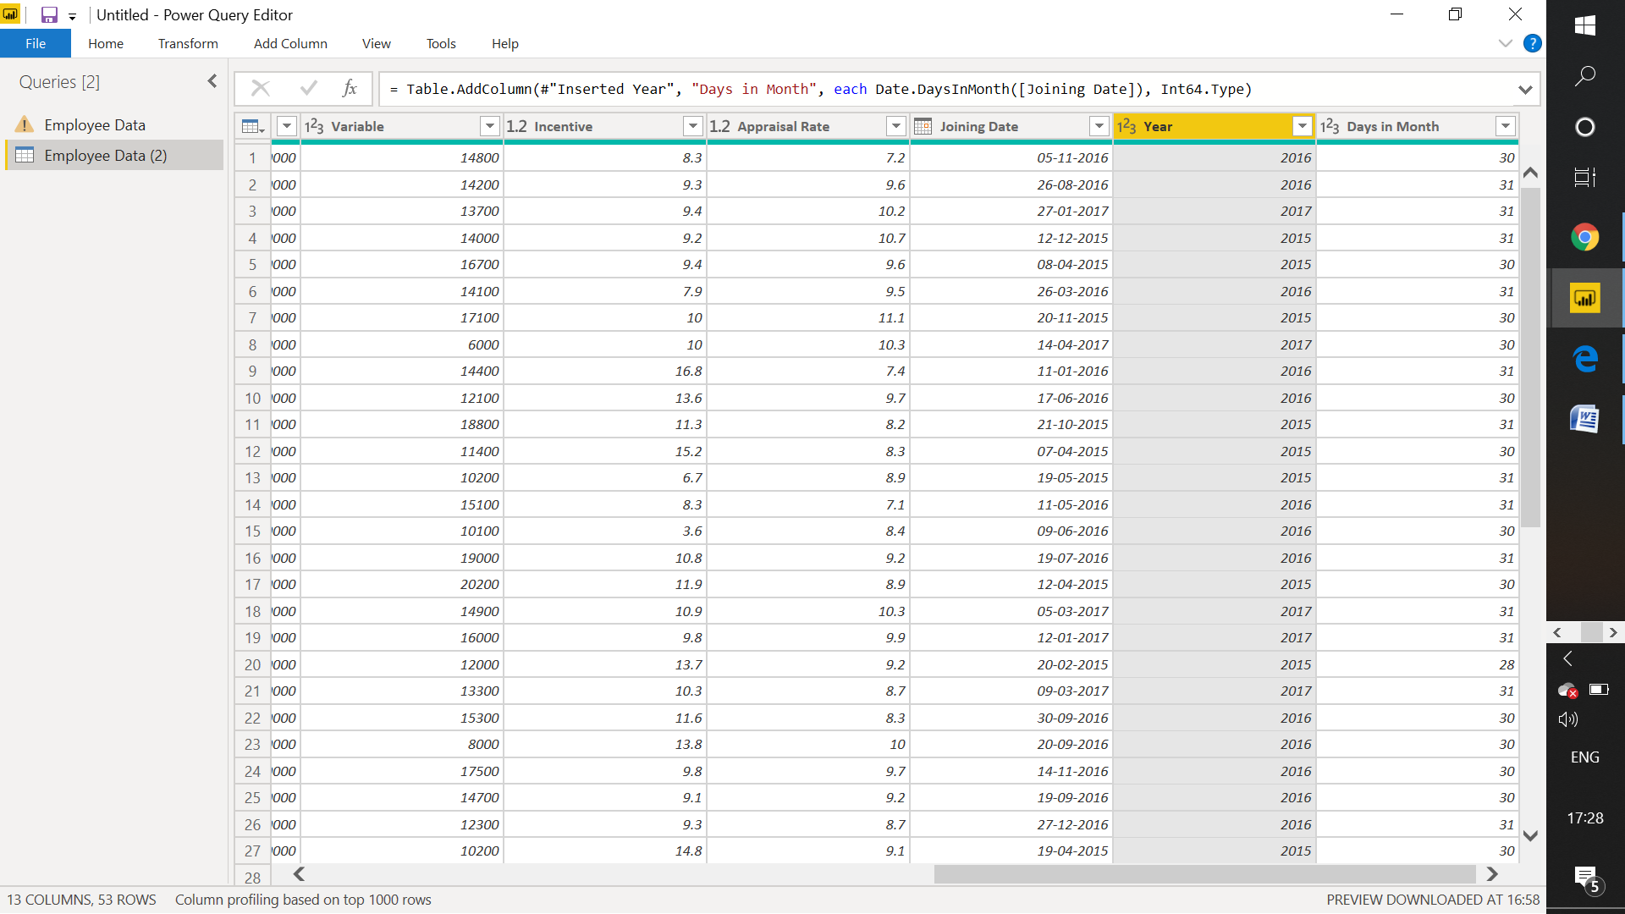

**− Create a visual of your choice and show the how much salary has been paid toeach state and which state has lowest payout**.

